Lab 3: Using EF Core CLI to Create and Apply Migrations

Install EF Core CLI:
dotnet tool install --global dotnet-ef --version 8.0.22
Create Migration:
dotnet ef migrations add InitialCreate
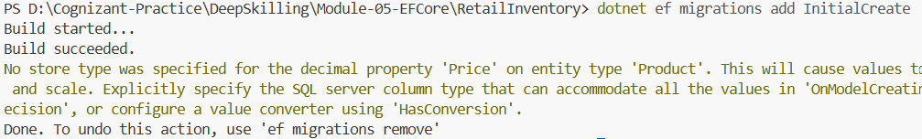

Apply Migration:
dotnet ef database update
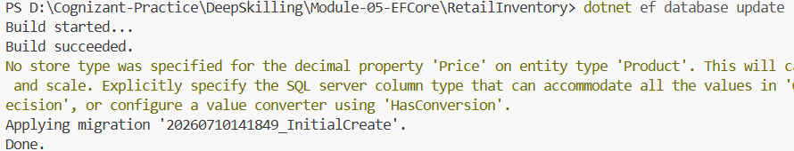
Output:
